**Attachments -**

* UI Layer - 
* Service Layer - 
* DB Layer - Not needed as application will create the db/table if not exist.
* PostMan configuration script - 
* Application Screenshots with docker - 
* Screenshots for Jenkins - 
* Load Test Report - 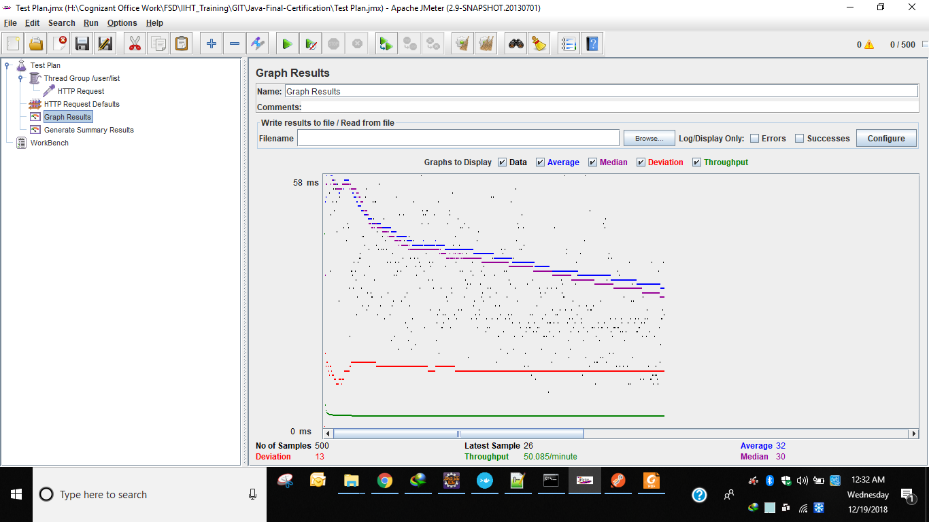

# [Java-Final-Certification](https://github.com/fsduseriiht/Java-Final-Certification) ****- git URL****

* https://github.com/fsduseriiht/Java-Final-Certification.git

Repo URL -

* https://github.com/fsduseriiht/project-manager-ui.git
* https://github.com/fsduseriiht/project-manager-backend.git

|  |
| --- |
| Please read the following carefully.  **While running the code in VLABs there is an issue with the port 8080 for BACKEND.**  **All references of 8080 has to be changed to 8081 for hitting any backend code and the database dialect used to run the backend code is - org.hibernate.dialect.MySQL5Dialect**  **Git repo is having default 8080 and OLDER MYSQL DB dialect as the development environment is necessitating the configurations.**  **I have set up dialect and port change locally on the Cloud Labs VM with the configurations and the application is running.**  **Default DB User/Password configured in application as -**  **Username - root**  **Password - admin**  But in Cloud Labs it(db credentials) needs changed to the one that is given as default by iiht |

# project-manager-ui

This is an angular js project. We will have to run the project by opening the home location of project in cmd prompt and then run

npm install

npm start

**If you are running the application from localhost the url needed to be hit to access the application is -**[**http://localhost:4200**](http://localhost:4200/)

**If you are running the application from Docker Tool Box for windows (for older windows versions), the url needed to be hit to access the application is -**[**http://192.168.99.100:4200**](http://192.168.99.100:4200/)

## The following should be executed / opened in browser only when your service layer is up and running:

{{baseurl}} = the context url with dns and port and application context

Example -

**Local PC** - http://localhost:8080/projectmanagerbackend/

**Docker Tool Box for older windows** - http://192.168.99.100:8080/projectmanagerbackend/

#### IF DATABASE IS EMPTY WE NEED TO hit the following services in the order given

###### The following services can be hit from Browser as well after bringing up the service, since, they are normal GET methods.

{{baseurl}}user/dump

{{baseurl}}parent/dump

{{baseurl}}project/dump

{{baseurl}}task/dump

**Information on docker commands and execution -**

# First Step - Go to UI project root folder and execute the build command in cmd prompt:

# ng build

## After build is done go for the following to execute in docker tool box.

## Docker for UI Layer

## General Commands to be executed in Docker related to push/build/run-

docker build -t your_image_name your_repo_url

docker tag your_image_name docker_username/your_image_name

docker push your_image_name docker_username/your_image_name

docker run -d -p 80:80/tcp -p 80:80/udp --name your_image_name your_image_id_value

# Example for push/build/run-

docker build -t project-manager-ui https://github.com/fsduseriiht/project-manager-ui.git

docker tag project-manager-ui amitabhadockerwork/project-manager-ui

docker push amitabhadockerwork/project-manager-ui

docker run -d -p 80:80/tcp -p 80:80/udp --name project-manager-ui_running <your_image_id_value>

# project-manager-backend

This is a spring boot project project using jdk1.8. We will have to run the project by opening the home location of project in cmd prompt and then run the following.

mvnw clean install

java -jar target\project-manager-backend-0.0.1-SNAPSHOT.war

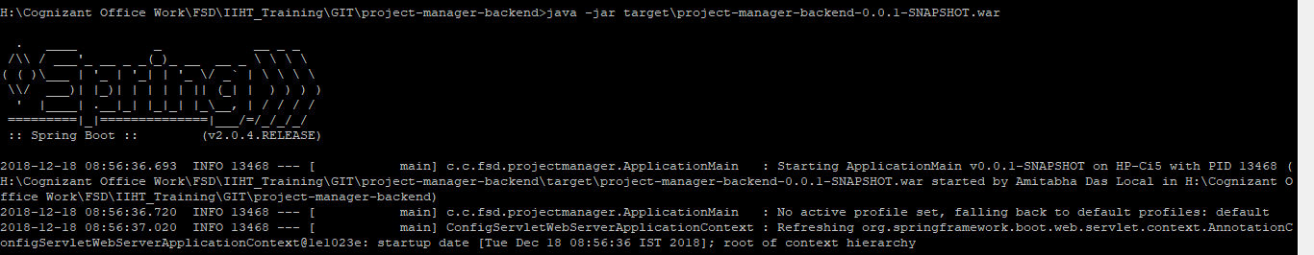

## Information on the services exposed -

{{baseurl}} = the context url with dns and port and application context

Example -

Local PC/Docker - http://localhost:8080/projectmanagerbackend/

Docker Tool Box for older windows - http://192.168.99.100:8080/projectmanagerbackend/

#### IF DATABASE IS EMPTY WE NEED TO hit the following services in the order given

###### The following services can be hit from Browser as well after bringing up the service, since, they are normal GET methods.

{{baseurl}}user/dump

{{baseurl}}parent/dump

{{baseurl}}project/dump

{{baseurl}}task/dump

###### The POSTMAN Collection can be imported into POSTMAN from the location -

* project-manager-backend/other-resources/postman-import-json_for_docker_toolbox/
* project-manager-backend/other-resources/postman-import-json_for_localhost/

#### User Related URLs

GET METHOD - {{baseurl}}user/dump - to pre-populate db with user details dump

GET METHOD - {{baseurl}}user/list - is used to display all records in user table db

POST METHOD - {{baseurl}}user/ - is used to create a single user record in user table in db

PUT METHOD - {{baseurl}}user/{{userId}} - is used to update the user table single record in db

DEL METHOD - {{baseurl}}user/{{userId}} - is used to delete single user record from user table in db

#### Parent Related URLs

GET METHOD - {{baseurl}}parent/dump - to pre-populate db with parent task details dump

GET METHOD - {{baseurl}}parent/list - is used to display all the parent task values in the db

POST METHOD - {{baseurl}}parent/ - is used to create a parent task in the db

PUT METHOD - {{baseurl}}parent/{{parentId}} - is used to update a parent task in the db

DEL METHOD - {{baseurl}}parent/{{parentId}} - is used to delete a parent task from the db

#### Project Related URLs

GET METHOD - {{baseurl}}project/dump - to pre-populate db with project details dump

GET METHOD - {{baseurl}}project/list - is used to display all records in project table db

POST METHOD - {{baseurl}}project/ - is used to create a single project record in project table in db

PUT METHOD - {{{baseurl}}project/{{projectId}} - is used to update the project table single record in db

DEL METHOD - {{baseurl}}project/{{projectId}} - is used to delete single project record from project table in db

#### Task Related URLs

GET METHOD - {{baseurl}}task/dump - to pre-populate db with task details dump

GET METHOD - {{{baseurl}}task/list - is used to display all records in task table db

GET METHOD - {{baseurl}}task/countperproject - is used to display count of records in task table db for each project

GET METHOD - {{baseurl}}task/list/{{projectId}} - is used to display records in task table db for particular {{projectId}}

POST METHOD - {{baseurl}}task/ - is used to create a single task record in task table in db

PUT METHOD - {{baseurl}}task/{{taskId}} - is used to update the task table single record in db

PUT METHOD - {{baseurl}}task/convert/{{taskId}} - is used to convert task with {{taskId}} in task table to a parent task, thereby purging the task details in task table

DEL METHOD - {{baseurl}}task/{{taskId}} - is used to delete record from TaskTable in db

### links related to docker: <https://cloud.docker.com/repository/docker/amitabhadockerwork/project-manager-backend>

### Docker pull from repo commands

### docker pull amitabhadockerwork/project-manager-ui

### docker pull amitabhadockerwork/project-manager-backend

## Docker for Service Layer - Project Manager Project

# General Commands to be executed in Docker related to push/build/run-

docker build -t your_image_name your_repo_url

docker tag your_image_name docker_username/your_image_name

docker push your_image_name docker_username/your_image_name

docker run --rm -i -t -d -p 8080:8080/tcp -p 8080:8080/udp --name your_image_name your_image_id_value

# Example for push/build/run-

docker build -t project-manager-backend https://github.com/fsduseriiht/project-manager-backend.git

docker tag project-manager-backend amitabhadockerwork/project-manager-backend

docker push amitabhadockerwork/project-manager-backend

docker run --rm -i -t -d -p 8080:8080/tcp -p 8080:8080/udp --name project-manager-backend_running <image_id>

# Database connectivity

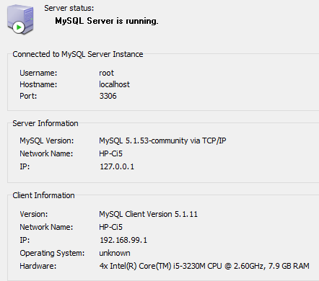 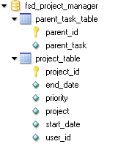 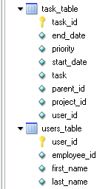

**DB USer - root**

**DB PAss - admin**

**Database version is 5.1.53**

To connect to this version I have used the dialect org.hibernate.dialect.MySQLDialect

If higher mysql is being used we can use the dialect org.hibernate.dialect.MySQL5Dialect

If mysql is not there in system then we can use H2 DB aswell. We will need to configure it in the following two places -

* /project-manager-backend/src/main/resources/application.properties
* /project-manager-backend/src/main/java/com/cts/fsd/projectmanager/ApplicationMain.java - setSpringBootApplicationConfiguration() method

**Note** - For Database, if you do not have MySql Installed in your system then you can use the H2 Database server profile also.

Only you have to hit the the following urls if you do not find any data at application start (in the order given below)-

1. http://localhost:8080/projectmanagerbackend/user/dump
2. http://localhost:8080/projectmanagerbackend/parent/dump
3. http://localhost:8080/projectmanagerbackend/project/dump
4. http://localhost:8080/projectmanagerbackend/task/dump

# All Information on #3 Deployment Submission

For Deployment you can use Docker as mentioned above.

You can also deploy locally as per following steps.

**For service layer -**

1. Pull from the git repo - **https://github.com/fsduseriiht/project-manager-backend.git**
2. Build using maven (mvnw) which is given as a part of the source code package. Set java home folder only if necessary in the mvnw.cmd file as per your own system. [**mvnw clean install**]
3. Go to target folder generated as a part of build result of the previous step and then execute the war file generated in the target folder as a result of the build process using [**java -jar <war file name>].**
4. Eg. - java -jar tasktracker-backend-0.0.1-SNAPSHOT.war
5. Check using post man or the logs in cmd prompt if the service is up or not.
6. Now start the ui application as follows.

**For UI - Layer -**

1. Pull from git repo - **https://github.com/fsduseriiht/project-manager-ui.git**
2. The build folder is already available in the folder from repo. All you need is to run **ng serve** command to run the UI application from command prompt
3. Hit the url - **http://localhost:4200**